***Iblis Appender***

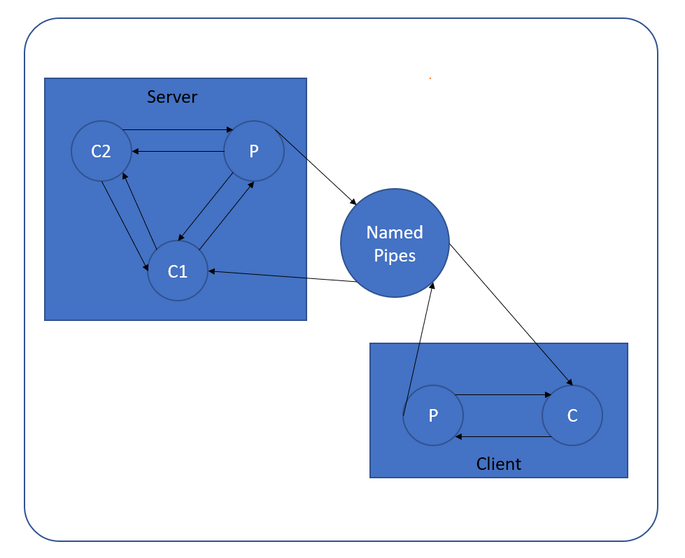

* *Named Pipes:*

*Permissions set to only read/write (execution not allowed) for only client & server*

*(no other process can have access)*

* *Client:*

*Takes in the name of the named pipe and a file1 name as cmd arg, parent reads content of file to named pipe for processing, sends child the parent pid and a signal that he has send the data and waits for response from the child that when received, can be displayed on screen. Child will receive data from named pipe and remove commas, & or dot from the received contents then it will display message “For Parent (pid) request, all parts removed”, before sending it to parent.*

* *Server:*

*Takes in the name of the named pipe and a file2 name as cmd arg, parent reads content of file and sends the length of file to child1 and contents of file to child2. Parent must receive a signal from child1 before it reads the results of child2 and send them as response to named pipe.*

*Child1 gets a length from parent, reads the data from named pipe but only forward data (specified by the length limit given from parent) to child2 and waits to receive a signal from child1 that it has received the data before terminating.*

*Child2 gets data from Child1 and data from parent and appends them, then sends it to parent, after that, it prints “Data Appended” before terminating.*